**DAILY ONLINE ACTIVITIES SUMMARY**

|  |  |  |  |  |  |  |
| --- | --- | --- | --- | --- | --- | --- |
| **Date:** | **05-06-2020** | | | **Name:** | **B.A.SOHANKUMAR** | |
| **Sem & Sec** | **4TH SEM A** | | | **USN:** | **4AL18CS013** | |
| **Online Test Summary** | | | | | | |
| **Subject** | | **----** | | | | |
| **Max. Marks** | | **----** | | **Score** | **----** | |
| **Certification Course Summary** | | | | | | |
| **Course** | **TIME SERIES ANALYSIS IN R** | | | | | |
| **Certificate Provider** | | | **GREAT LEARNING ACADEMY** | **Duration** | | **5 HOURS** |
| **Coding Challenges** | | | | | | |
| **Problem Statement:1:Write a java program to find duplicate character in a string.** | | | | | | |
| **Status: EXECUTED** | | | | | | |
| **Uploaded the report in Github** | | | | **YES** | | |
| **If yes Repository name** | | | | **LOCKDOWN CODING** | | |
| **Uploaded the report in slack** | | | | **YES** | | |

**ONLINE COURSE DETAILS:**

Course:TIME SERIES ANALYSIS IN R

Today I have started with this new course.This course has 5 hours of video content and 13 topics.I have completed with 7 topics that are Why Time series is important,Base of Time series Analytics,Introduction to Time series forecasting,Approaches used for Time Series forecasting,Decomposition Method,Irregularity concept in decomposition method,Case study on Decomposition method.

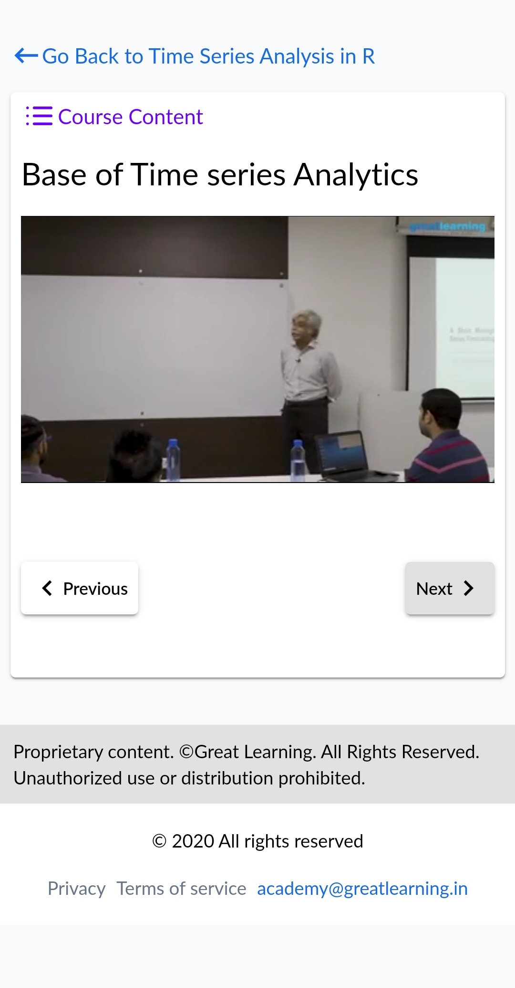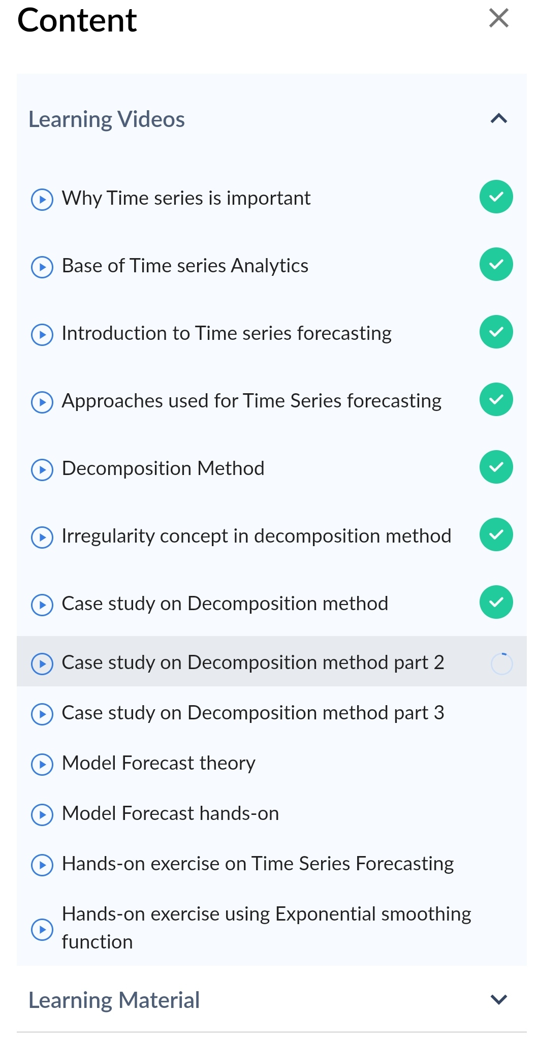

**CODING CHALLENGE DETAILS:**

1.Write a Java Program to find the duplicate characters in a string.

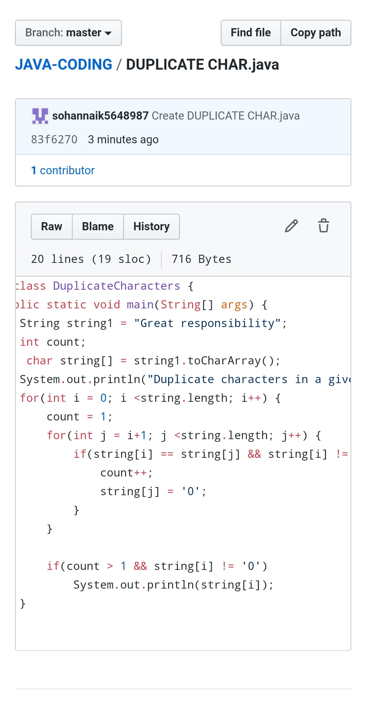

REPOSITORY LINK:https://github.com/sohannaik5648987/JAVA-CODING